10048-HM Stainless Steel Double Bowl Kitchen Sink with Drainer (without Faucet)
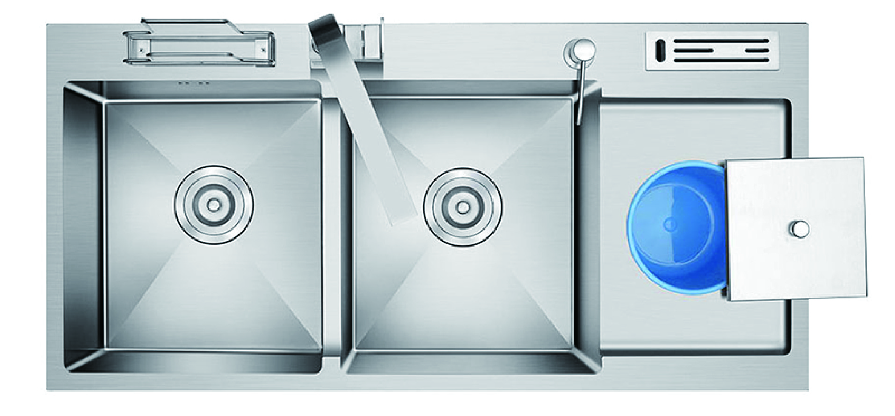

To ensure the suitability of our products for your space, please verify the measurements of the product and match them with your kitchen cabinet dimensions, and some products may not require high accuracy, but it is still important to check.

Think about the convenience of a kitchen sink with a drainer. The Stainless-Steel Double Bowl Kitchen Sink with Drainer offers anti-condensation paint for mold and moisture proofing, making it both practical and easy to clean. This silver sink is ideal for busy kitchens, combining functionality with a sleek design.
Product DetailsProduct Color may vary slightly due to photographic lighting sources or your monitor/screen settings.Brand: Wonderful KitchensModel Number: 10048-HMColor: silverMade in: ChinaMaterial: Stainless steelProduct Dimensions: 100*48cm

