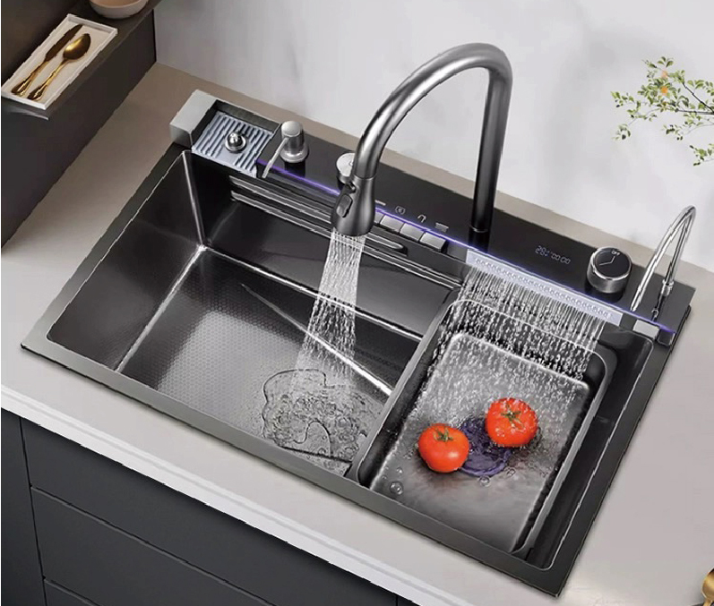
B-HM Digital Display Stainless Steel Nano Multi-Function Kitchen Sink 304 stainless steel with Faucet

To ensure the suitability of our products for your space, please verify the measurements of the product and match them with your kitchen cabinet dimensions, and some products may not require high accuracy, but it is still important to check.

Imagine your kitchen transforming into a seamless workflow with the Digital Display Stainless Steel Nano Multi-Function Kitchen Sink. Picture yourself effortlessly washing, cutting, and draining all at once. With its sleek white finish and nano-cleanliness, maintaining a spotless kitchen has never been easier. Made from durable 304 stainless steel, this sink is as functional as it is beautiful. Available in 750*460*220 and 820*460*220, it’s designed to make your life simpler and more elegant.
Product DetailsProduct Color may vary slightly due to photographic lighting sources or your monitor/screen settings.Brand: Wonderful KitchensModel Number:7546-HM/8246-HMColor: Black/Gold/WhiteMaterial: Stainless steel 304Made in: China

