S-3833 Premium Stainless Steel Single Bowl Kitchen Sink (Sink Only)
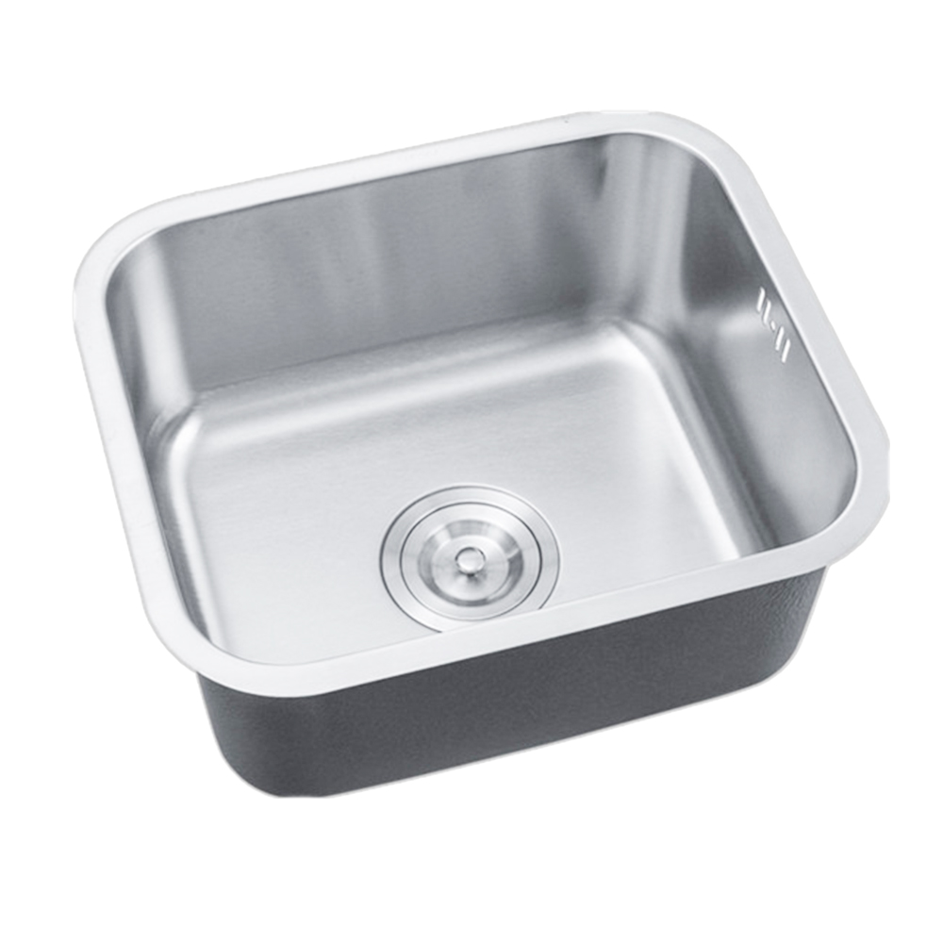
To ensure the suitability of our products for your space, please verify the measurements of the product and match them with your kitchen cabinet dimensions, and some products may not require high accuracy, but it is still important to check.Picture a kitchen sink that’s both stylish and soundproof. The Premium Stainless Steel Single Bowl Kitchen Sink features advanced soundproofing with StoneGuard undercoat and sound-absorbing pad. Made from corrosion-resistant stainless steel, it’s perfect for washing and food prep, making your kitchen quieter and more efficient.
Product Details Product Color may vary slightly due to photographic lighting sources or your monitor/screen settings.Brand: Wonderful KitchensModel Number: S-3833Color: silverMade in: ChinaMaterial: Stainless steelProduct Dimensions: 380*330mm

